** SUNRISE ENGLISH PRIVATE SCHOOL, ABU DAHBI (2020-21)**

**Subject: EVS Grade 2 ________**

**Date of submission: Worksheet No: 3**

**Lesson no : 1- Our body - Posture Roll No: ______**

**Teacher’s remarks and sign: ____________ Name: _______________**

**I. Fill in the blanks.**

1. ______________is the way we position our body while sitting standing or walking.
2. We should always maintain a good ___________.
3. _________________boosts our self – confidence.
4. Good posture is very important to maintain a healthy ___________and ________________.

**II. Write T for true or F for false**

1. Good posture does not help us to avoid back ache or neck pain.__________
2. We should always slouch while standing._______
3. Good posture makes us look smart.________
4. **Tick (√) the correct posture**

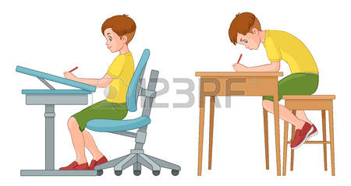

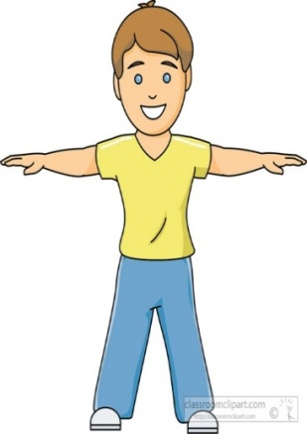 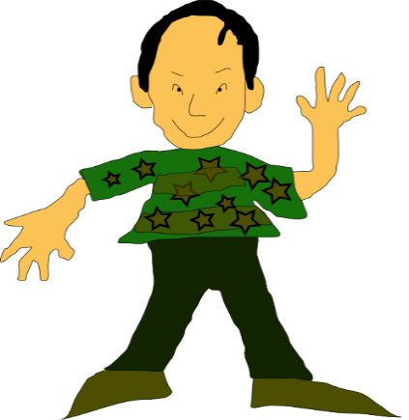

1. **Answer the following**
2. **What do you mean by posture? Write the importance of a good posture.**

**Ans. _______________________________________________________**

**____________________________________________________**

**____________________________________________________**

**_____________________________________________________**